**GEOGRAPHIC INFORMATION SYSTEMS 1 – SCIENTIFIC DATA**

**UMEÅ UNIVERSITY – DEPARTMENT OF ECOLOGY & ENVIRONMENTAL SCIENCE**

**LAB4 – ASSIGNMENT 4**

**LAB4.1 Reading Comprehension**

**LAB4.2 Lab4 questions**

**LAB4.3 ArcGIS maps**

**LAB4.4 Map questions**

**LAB4.1 – READING COMPREHENSION**

**An overview of scale, pattern, process relationships in geomorphology: a remote sensing and GIS perspective. Walsh SJ, Butler DR, Malanson GP. 1998.**

**Accuracy assessment of georectified aerial photographs: implications for measuring lateral channel movement in a GIS. Hughes ML, McDowell PF, Marcus WA. 2006.**

**LAB4.1.1**

**Discuss two ways in which it can be advantageous to include remote sensing and GIS geomorphological studies as compared to only field studies.**

Two ways in which a combination of RS and GIS techniques with field studies can be an advantage are:

1. On the one hand, RS and GIS techniques *“allow geomorphologists to examine* ***spatial relationships*** *at a variety of scales that would not be feasible using only fieldwork or traditional aerial photography”* (S.J. Walsh et al., 1998, p201)1.
2. On the other, *“****temporal changes*** *can also be examined effectively, as sequential images provide insights into process and pattern”* (S.J. Walsh et al., 1998, p201)1, e.g. *“GIS database elements can be used to represent temporal dimensions of the landscape”* (S.J. Walsh et al., 1998, p185)1, such as debris flow chronologies or vegetation regeneration estimates after forest fires. Integration of fieldwork / RS data collection and GIS techniques enhance the analytical power of the whole system.

However, there are still factors that make fieldwork essential in geomorphological studies, such as *“spatial- and temporal-scale limitations of RS data”* (S.J. Walsh et al., 1998, p184)1, e.g. capture and storage limitations that most of satellites have for certain image resolutions.

Therefore, best of **both** data collection worlds, fieldworks and the techniques of RS and GIS, should be utilised, in order to have a *“greater likelihood of answering important scientific questions that may escape observation and measurement if only fieldwork or RS-GIS techniques are employed”* (S.J. Walsh et al., 1998, p184)1.

**LAB4.1.2**

**As discussed by Hughes et al. (2006), describe three factors that need to be considered when selecting ground control points for georeferencing (georectification) of aerial photos. Be sure to mention what should be taken into account in these three factors to ensure accurate georectification.**

1. Leys and Werrity (1999)3 consider that Georectification Control Points “*should be widely distributed across the image to provide a ‘stable warp’*” (Hughes et al., 2006, p3)2, which should mean, as per these authors, that the more points that are used, the more accurate the georectification is made.
2. Richards (1986)4 and Campbell (2002)5 suggest that *“the majority of control points should be located around the edge of the image with several uniformly spaced points in its central portion”*, which could mean that while the edge would be accurate, this could be at expense of other parts in the middle of the image, that could be skewed or deformed.
3. By concentrating GCPs near the features of interest rather than across the entire aerial photo. This method is particularly more effective with river channels, where accuracy along its edge is absolutely required, as well as with historical aerial photos. (*)

(*) While options 1 and 2 *“may be appropriate for satellite images that have relatively little error du to topographic variations, or for scanned maps with constant scale variations across their projections, they are not necessarily well suited for historical aerial photos”* (Hughes et al., 2006, p4)2.

**REFERENCES**

1. Walsh SJ, Butler DR, Malanson GP. 1998. An overview of scale, pattern, process relationships in geomorphology: a remote sensing and GIS perspective. Geomorphology 21, 183-205.
2. Hughes ML, McDowell PF, Marcus WA. 2006. Accuracy assessment of georectified aerial photographs: implications for measuring lateral channel movement in a GIS. Geomorphology 74, 1-16.
3. Leys, K.F., Werrity, A., 1999. River channel planform change: software for historical analysis. Geomorphology 29, 107– 120.
4. Richards, J.E., 1986. Remote Sensing Digital Image Processing: An Introduction. Springer, New York.
5. Campbell, J.B., 2002. Introduction to Remote Sensing, 3rd edition. The Guilford Press, New York.

**LAB3.2.1 Lab3 Q1 – Metadata: Table of files**

**Create a table of your files used and created in this lab. Make sure your table contains the same five columns as the metadata table from the past labs: name of file, projection/coordinate system, description of data in the file, source (course folder or the file(s) that you manipulated to form the new file), tool/method used to create the file.**

A preview of the created excel schedule, including received and newly created filed, can be seen hereunder. The full excel file has been also included in the submission in the Drop Box.

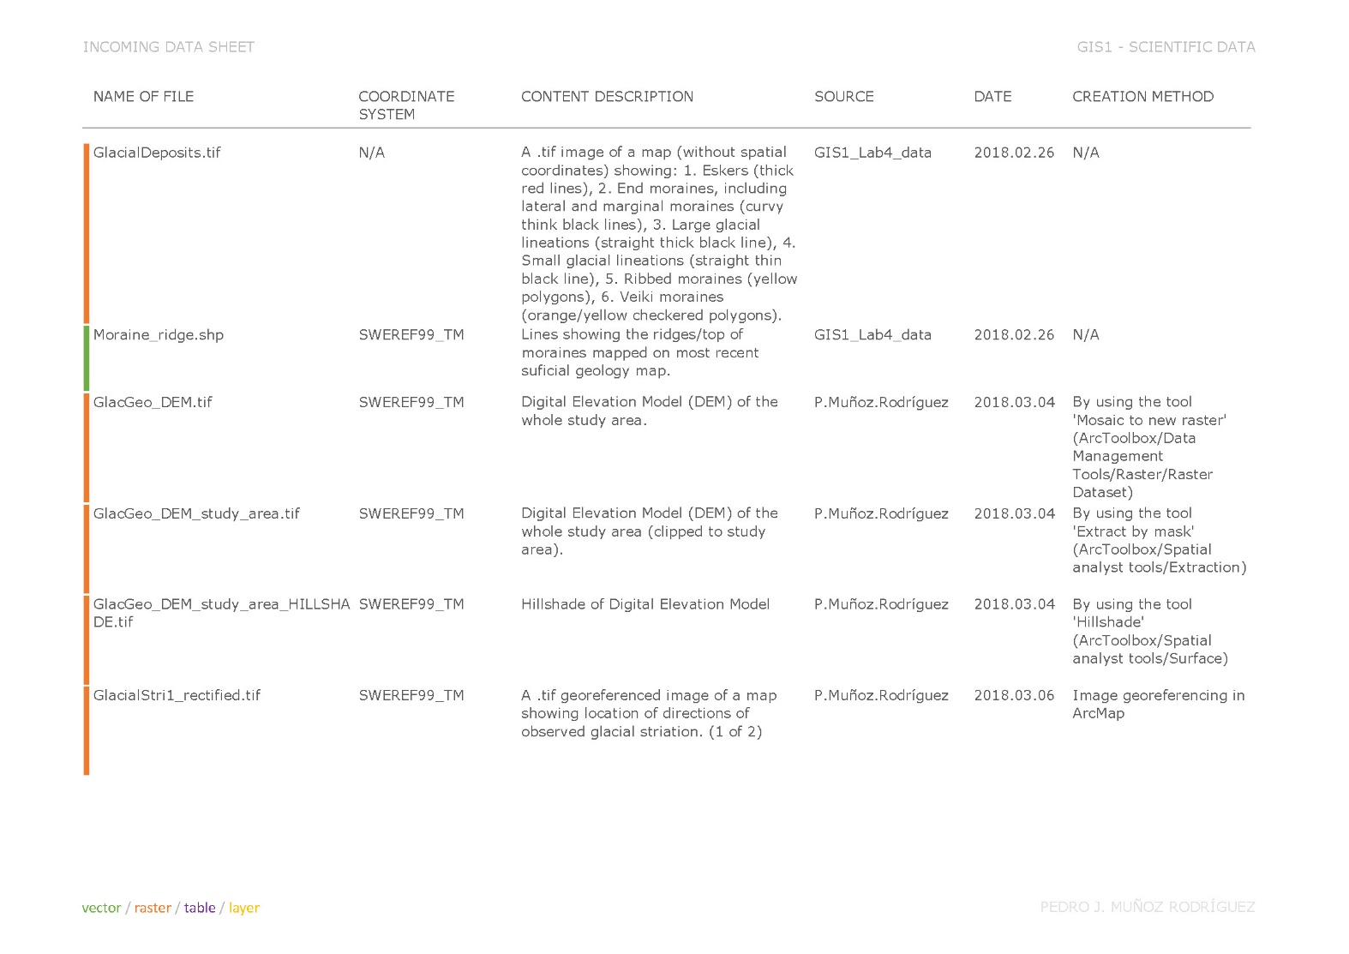

**LAB3.2.2 Lab3 Q2 – Elevation under ‘j’ in ‘Björksele’**

**Add the DEMs and the General map (GlacGeo_GenMap) to your map. Determine the elevation of a pixel as close as possible to the middle of the dot over the ‘j’ in the town name ‘Björksele’ that is labeled on the General map. Björksele is located along the Vindel River within the Glacial_geo_studyarea polygon.**

The elevation of the pixel located at this point is 274.39m, as per calculation below.

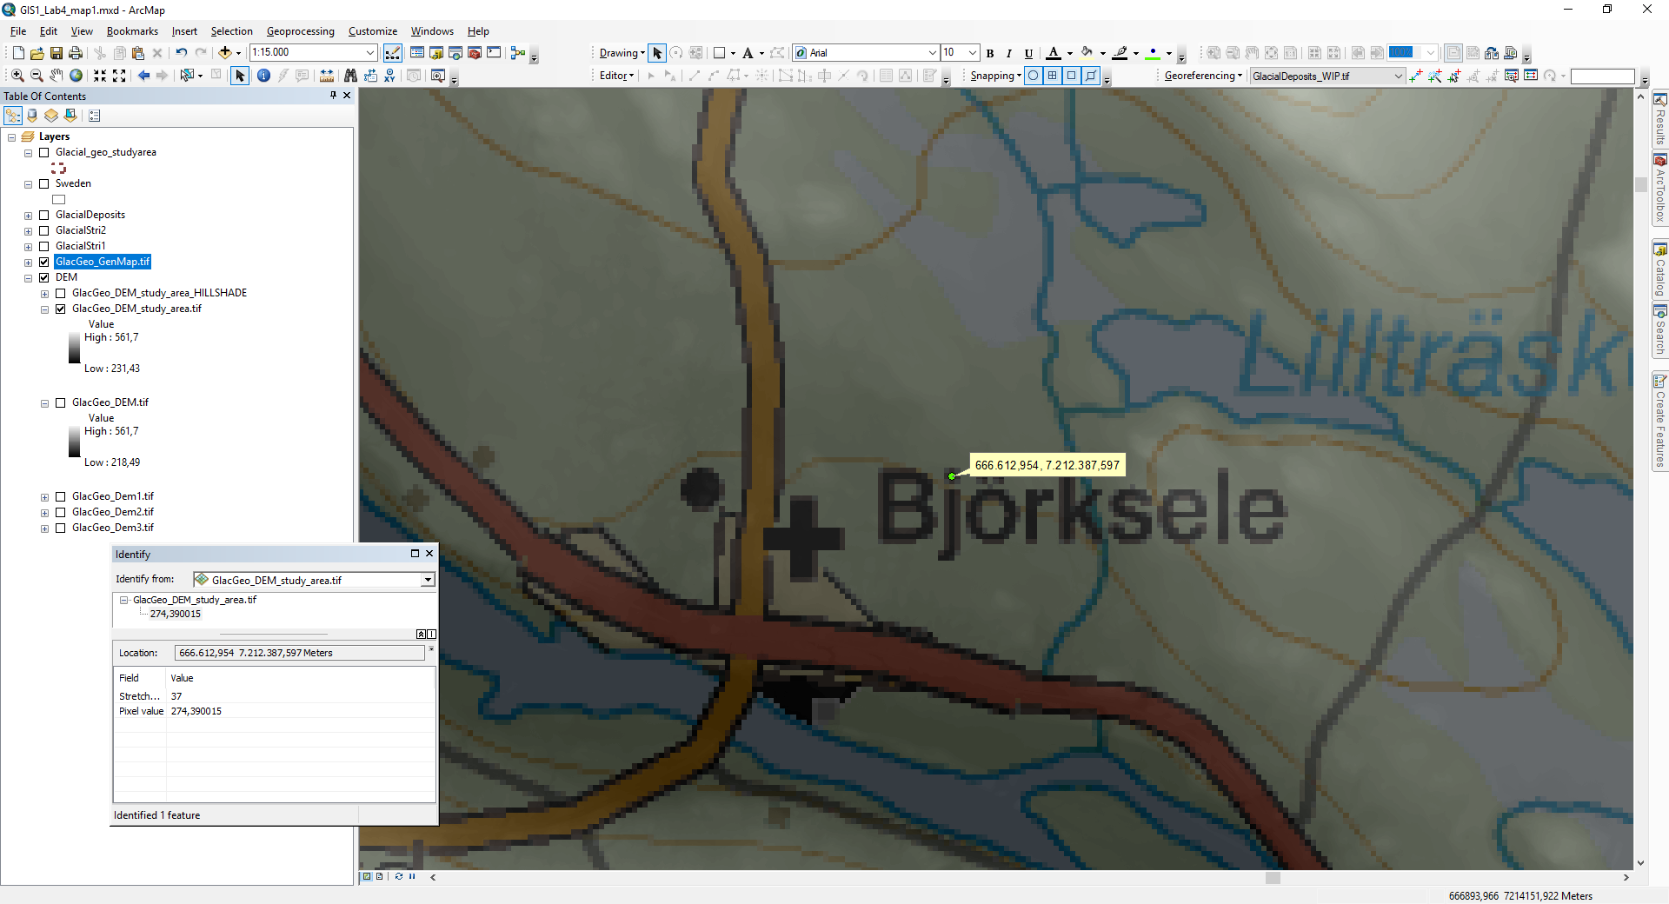

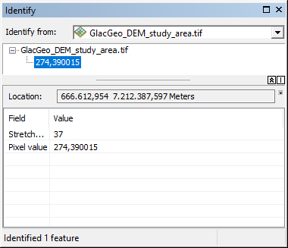

**LAB3.2.3 Lab3 Q3 – Screenshots of link tables**

**Include a screenshot of your final ‘Link Table’ for each of your georeferenced maps, showing all of your links (control points) and the RMSE.**

Link table of GlacialStri1_rectified.tif (georeferenced from GlacialStri1.tif)

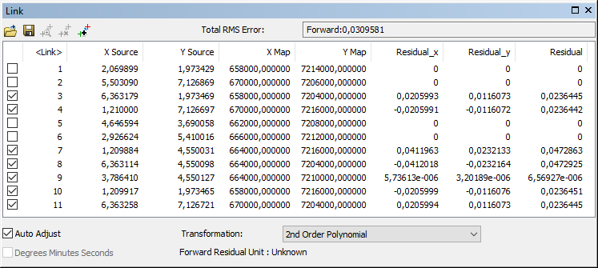

The following map screenshot shows where these control points have been located on the map.

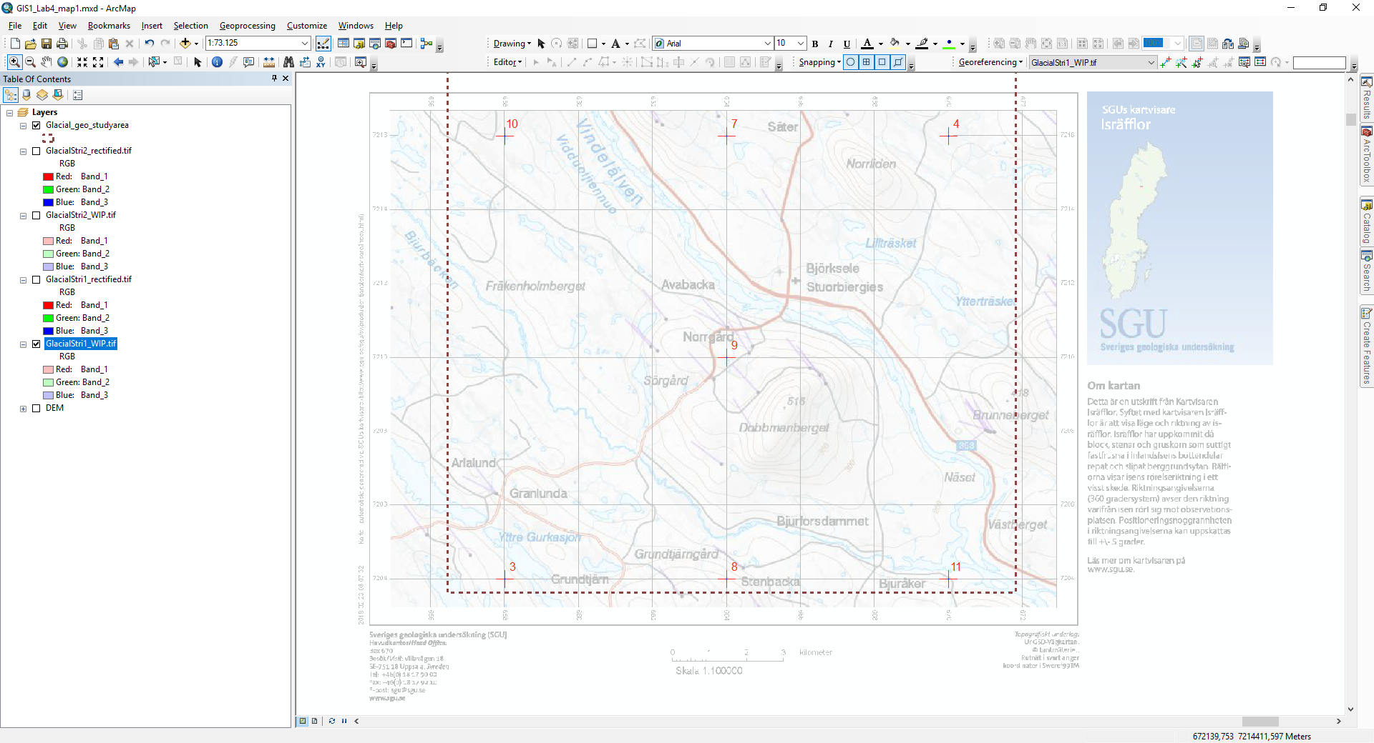

Link table of GlacialStri2_rectified.tif (georeferenced from GlacialStri2.tif)

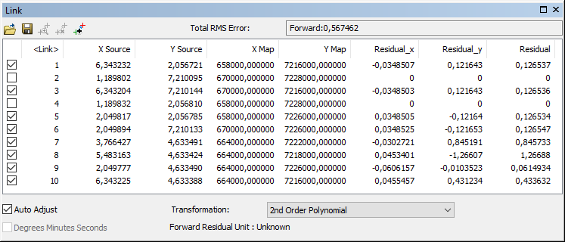

The following map screenshot shows where these control points have been located on the map.

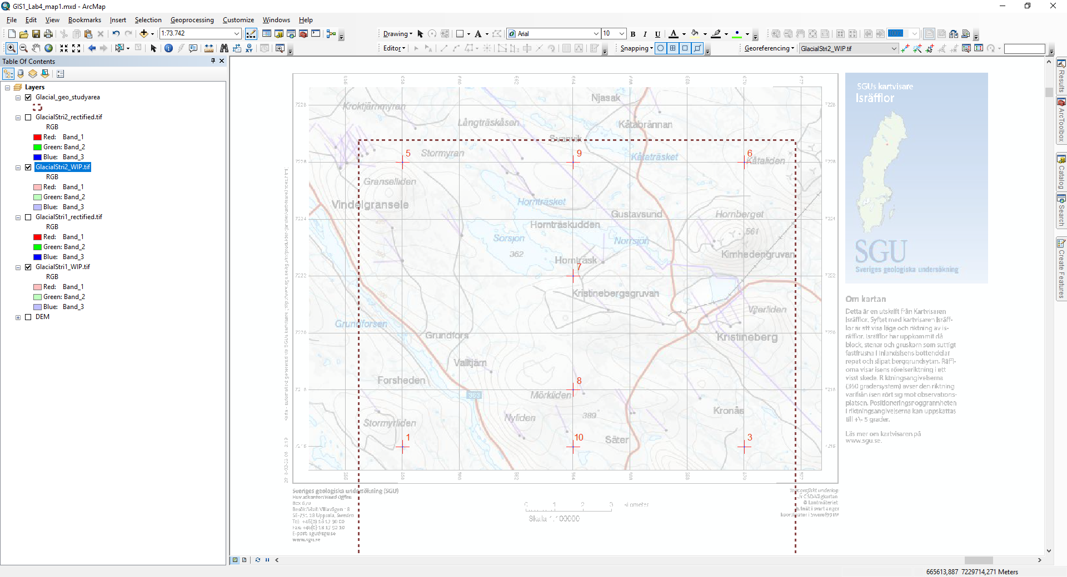

Link table of GlacialDeposits_rectified.tif (georeferenced from GlacialDeposits.tif).

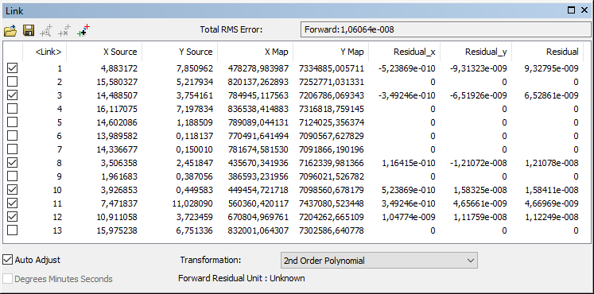

The following map screenshot shows where these control points have been located on the map.

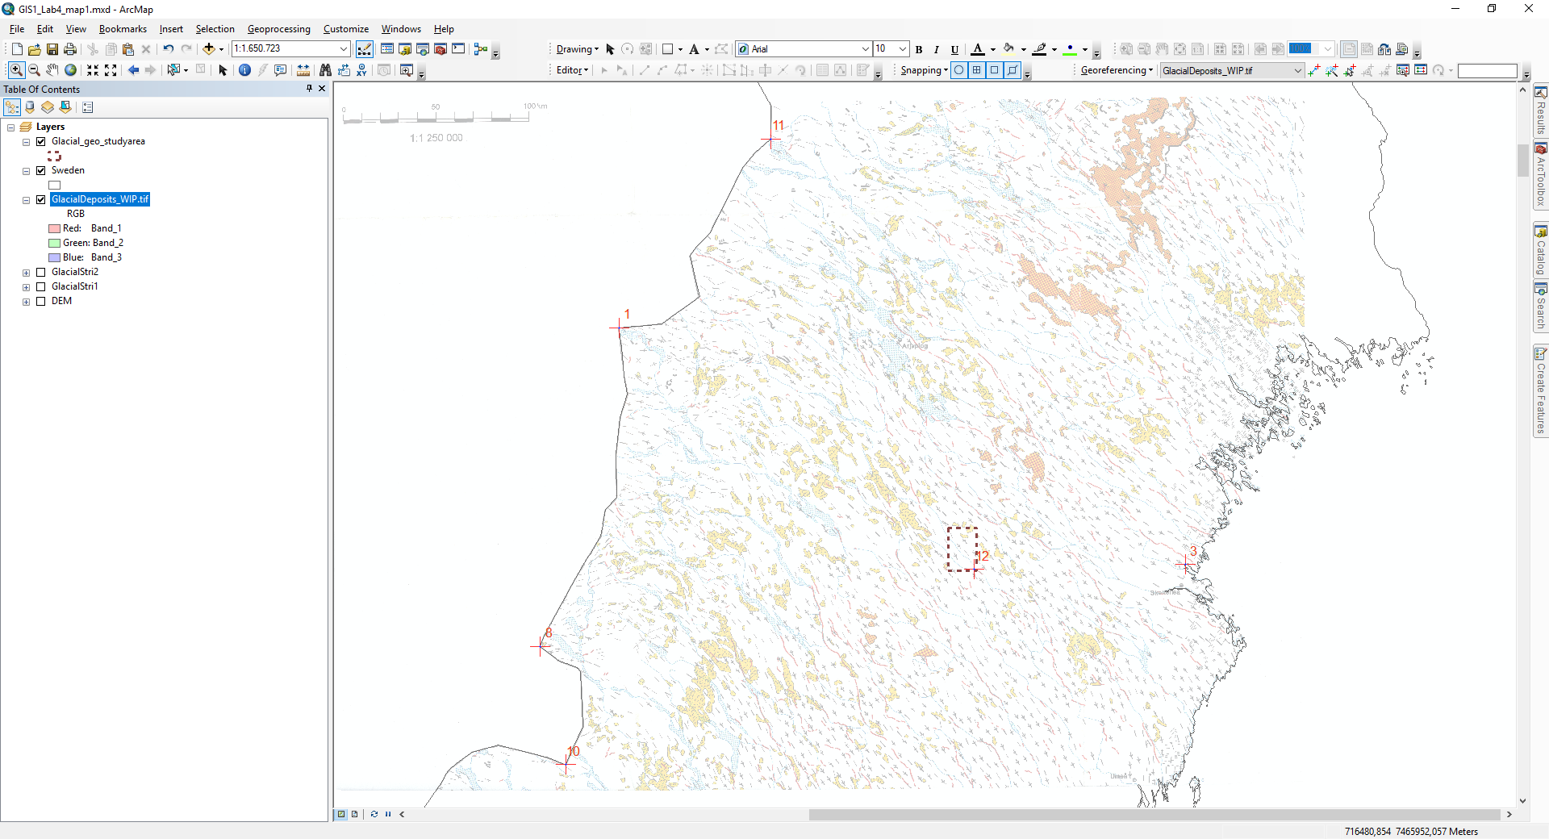

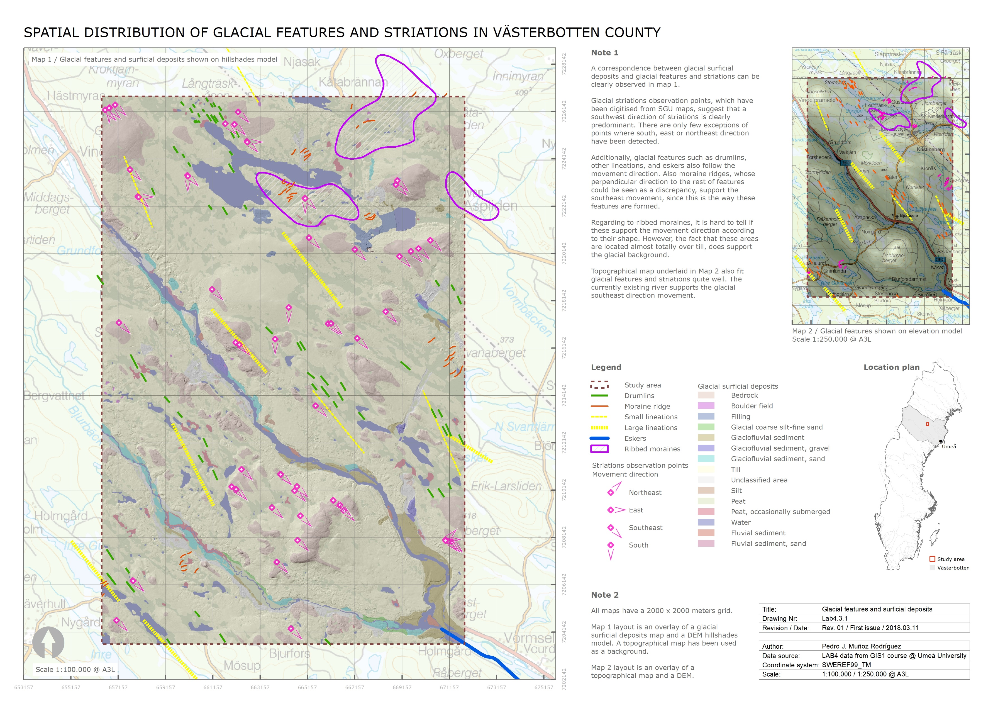

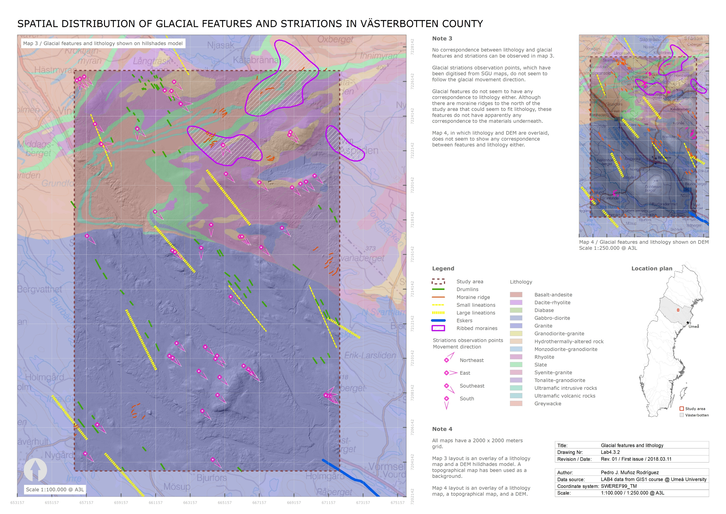

**LAB4.4 – MAP QUESTIONS**

**LAB4.4.1**

**Map layout explanation: include a short explanation of your map layout. How does your map layout and design help you to communicate the purpose of your maps based on the 6 Cs?**

Both layouts Lab4.3.1 and Lab4.3.2 follow a similar structure and have been designed to give answer to all questions about glacial features and striations within the study area.

Regarding to map styles, the selected contrast between pale graded colours used for background maps, and the bright palette of colours used for striations and features, enhances the readability of these layouts and therefore its capacity to communicate their purposes.

In layout **Lab4.3.1**, maps 1 and 2 show different overlaid information. The purpose of this layout is to **support the correspondence** between surficial geology and glacial features / striations. On the one hand, map one compares features and striations, which have been previously georeferenced and digitised, with an overlay of glacial surficial geology map and a DEM hillshades model. In order to support this information, map 2 compares the same features and striations with an overlay of the DEM and the topographical map (also georeferenced), so that this comparison supports the detected glacial movement direction.

The layout key has been designed by making three groups of legend features: one with glacial features and striations, another one movement direction observation points, and a third one with glacial surficial deposit types.

In layout **Lab4.3.2**, maps 3 and 4 also show different overlaid layers. However, the purpose of this layout is actually the opposite: this layout has been designed to **support the lack of correspondence** between lithology and glacial features / striations.

In this case, the layout key has been designed by making three groups of legend features: one with glacial features and striations, another one movement direction observation points, and a third one with lithology classification.

In both Lab4.3.1 and Lab4.3.2, when it comes to clipping the different layers to the study area, as the DEM as most of shapefiles have been clipped strictly to this study area rectangle. However, glacial features shapefiles, which have been georeferenced and digitised, have been treated differently. Since small portions of certain features, such as moraines, lineations, or eskers, would not give any information to the map user, the entire geometry of these features has been depicted, even when some of them are partially outside of the study area.

Also in both, some additional notes have been also included to give extra support to the information shown in maps.

**LAB4.4.2**

**How well do the georeferenced glacial features/striations fit with those from the shapefiles of drumlins and moraines? If there are any discrepancies, give one possible explanation for this.**

In general, there is a good correspondence between shapefiles of drumlins and moraines, and georeferenced / digitised glacial striations and features, although some comments about particular cases could be added.

Regarding to drumlins shapefiles, these do follow the same direction as georeferenced and digitised lineations. However, they do not seem to be represented in the same locations, which could be due to the scale of the raster map.

Additionally, georeferenced and digitised moraine ridges do not follow the same direction as the rest of features and striations. However, they seem to be perpendicular to the rest of features due to their own characteristics of formation.

**LAB4.4.3**

**Which factor (lithology, surficial geology, topography) best corresponds to the spatial distribution and direction of glacial features/striations? Give specific examples from your map to support your argument.**

**Surficial geology vs. glacial features and striations**

According to the graphical information received and analysed, surficial geology seems to be the factor that best corresponds to the spatial distribution and direction of glacial features and striations, as it can be observed on maps 1 and 2 of LAB4.3.1.

First of all, glacial striations observation points, which have been digitised from SGU maps, suggest that a southwest direction of striations is clearly predominant. There are only few exceptions of points where south, east or northeast direction have been detected. Please see map 1 of LAB4.3.1.

Additionally, glacial features such as drumlins, other lineations, and eskers also follow the movement direction. Also moraine ridges, whose perpendicular direction to the rest of features could be seen as a discrepancy, support the southeast movement, since this is the way these features are formed. Please see map 1 of LAB4.3.1.

Regarding to ribbed moraines, it is hard to tell if these support the movement direction according to their shape. However, the fact that these areas are located almost totally over till, does support the glacial background. Please see map 1 of LAB4.3.1.

Looking at topographical map underlaid in map 2 of LAB4.3.1, it also fits glacial features and striations quite well. The currently existing fluvial structure supports glacial southeast direction movement.

**Lithology vs. glacial features and striations**

Finally, no correspondence between lithology and glacial features and striations can be observed in maps 3 and 4 of LAB4.3.2.

Glacial striations observation points, which have been digitised from SGU maps, do not seem to follow the glacial movement direction.

Glacial features do not seem to have any correspondence to lithology either. Although there are moraine ridges to the north of the study area that could seem to fit lithology, these features do not have apparently any correspondence to the materials underneath.

Map 4 of LAB4.3.2, in which lithology and DEM are overlaid, does not seem to show any correspondence between features and lithology either.